Chapter 5, Problem 34.

Given the op amp circuit shown in Fig. 5.72, express v_{o} in terms of v₁ and v₂.

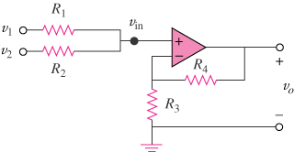

Figure 5.72
For Prob. 5.34.

